電通二甲微處理器實驗 實驗結報

實驗名稱 | 走馬燈
組別 | 33 | 組員 | 04050760呂睿中，04052520楊適名

- 實驗目的
Arduino UNO D1 – D8 分別接到 LED，實作跑馬燈展 示。
- 實驗步驟
實驗1. LED 向左及向右執行花色展示
實驗2. 執行自定花色展示: 所有LED亮滅兩次 -> 左移八次 -> 所有LED亮 滅兩次 -> 右移八次
實驗3. Arduino 接上一個開關，開關 OFF -> LED 向左及向右執行花色展示， 開關 ON -> 執行自定花色展示

- 程式碼
實驗一
// Pin 13 has an LED connected on most Arduino boards.
// give it a name:
int led[8] = {2,3,4,5,6,7,8,9};
int i,num;
// the setup routine runs once when you press reset:
void setup() {
// initialize the digital pin as an output.
for (i=0;i<8;i++)
{
pinMode(led[i], OUTPUT);
}
}

// the loop routine runs over and over again forever:
void loop() {

for (num=0;num<1;num++){ //左移8次
for (i=0;i<=7;i++){
digitalWrite(led[i], HIGH); // turn the LED on (HIGH is the voltage level)
delay(100); // wait for a second
digitalWrite(led[i], LOW); // turn the LED off by making the voltage LOW
delay(100); // wait for a second
}
}

for (num=0;num<1;num++){ //右移2次
for (i=7;i>=0;i--){
digitalWrite(led[i], HIGH); // turn the LED on (HIGH is the voltage level)
delay(100); // wait for a second
digitalWrite(led[i], LOW); // turn the LED off by making the voltage LOW
delay(100); // wait for a second
}
}
}

實驗二
// Pin 13 has an LED connected on most Arduino boards.
// give it a name:
int led[8] = {2,3,4,5,6,7,8,9};
int i,num;
// the setup routine runs once when you press reset:
void setup() {
// initialize the digital pin as an output.
for (i=0;i<8;i++)
{
pinMode(led[i], OUTPUT);
}
}

// the loop routine runs over and over again forever:
void loop() {
for (num=0;num<2;num++){ //全亮滅2次
for (i=7;i>=0;i--){
digitalWrite(led[i], HIGH); // turn the LED on (HIGH is the voltage level
}
delay(1000);
for (i=7;i>=0;i--){
digitalWrite(led[i], LOW); // turn the LED on (HIGH is the voltage level
}
delay(1000);
}
for (num=0;num<1;num++){ //左移8次
for (i=0;i<=7;i++){
digitalWrite(led[i], HIGH); // turn the LED on (HIGH is the voltage level)
delay(100); // wait for a second
digitalWrite(led[i], LOW); // turn the LED off by making the voltage LOW
delay(100); // wait for a second
}
}
for (num=0;num<2;num++){ //亮滅2次
for (i=7;i>=0;i--){
digitalWrite(led[i], HIGH); // turn the LED on (HIGH is the voltage level
}
delay(1000);
for (i=7;i>=0;i--){
digitalWrite(led[i], LOW); // turn the LED on (HIGH is the voltage level
}
delay(1000);
}
for (num=0;num<1;num++){ //右移2次
for (i=7;i>=0;i--){
digitalWrite(led[i], HIGH); // turn the LED on (HIGH is the voltage level)
delay(100); // wait for a second
digitalWrite(led[i], LOW); // turn the LED off by making the voltage LOW
delay(100); // wait for a second
}
}
}

實驗三
// Pin 13 has an LED connected on most Arduino boards.
// give it a name:
int led[8] = {2,3,4,5,6,7,8,9};
int i,num;
// the setup routine runs once when you press reset:
void setup() {
// initialize the digital pin as an output.
for (i=0;i<8;i++)
{
pinMode(led[i], OUTPUT);
}
pinMode(13,INPUT);
Serial.begin(9600);
for (i=0;i<8;i++)
{
digitalWrite(led[i], LOW);
}
}

// the loop routine runs over and over again forever:
void loop() {

if(digitalRead(13)==0)
{
/*for (num=0;num<2;num++){ //全亮滅2次
for (i=7;i>=0;i--){
digitalWrite(led[i], HIGH); // turn the LED on (HIGH is the voltage level
}
delay(1000);
for (i=7;i>=0;i--){
digitalWrite(led[i], LOW); // turn the LED on (HIGH is the voltage level
}
delay(1000);
}*/

for (i=0;i<=7;i++){
if(digitalRead(13)==1)
{
break;
}
else
{
digitalWrite(led[i], HIGH); // turn the LED on (HIGH is the voltage level)
delay(100); // wait for a second
digitalWrite(led[i], LOW); // turn the LED off by making the voltage LOW
delay(100);
// wait for a second
}
}
/* for (num=0;num<2;num++){ //亮滅2次
for (i=7;i>=0;i--){
digitalWrite(led[i], HIGH); // turn the LED on (HIGH is the voltage level
}
delay(1000);
for (i=7;i>=0;i--){
digitalWrite(led[i], LOW); // turn the LED on (HIGH is the voltage level
}
delay(1000);
}*/

for (i=7;i>=0;i--){
if(digitalRead(13)==1)
{
break;
}
else
{
digitalWrite(led[i], HIGH); // turn the LED on (HIGH is the voltage level)
delay(100); // wait for a second
digitalWrite(led[i], LOW); // turn the LED off by making the voltage LOW
delay(100); // wait for a second
}
}

}
else
{
for (num=0;num<2;num++){ //全亮滅2次
for (i=7;i>=0;i--){
digitalWrite(led[i], HIGH); // turn the LED on (HIGH is the voltage level
}
delay(1000);
for (i=7;i>=0;i--){
digitalWrite(led[i], LOW); // turn the LED on (HIGH is the voltage level
}
delay(1000);
}

}
}

- 實驗結果及分析
實驗一 LED 向左及向右花色展示
實驗二 所有LED亮滅兩次然後左移八次然後LED再亮滅兩次，最後右移八次
實驗三 接上開關，開關 OFF， LED 向左及向右花色展示， 開關 ON ，執行自定花色展示

- 心得討論
這次學會了運用修改程式碼以達到LED燈花色不同的展示
再運用開關執行不同的花色展示
沒想到簡單的LED展示需要那麼長的程式碼，眼睛快花了!
修正電路圖
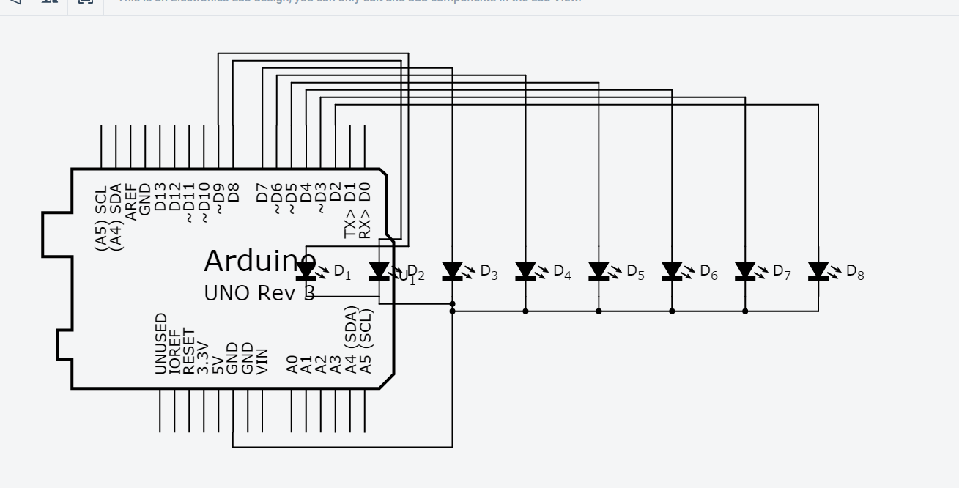
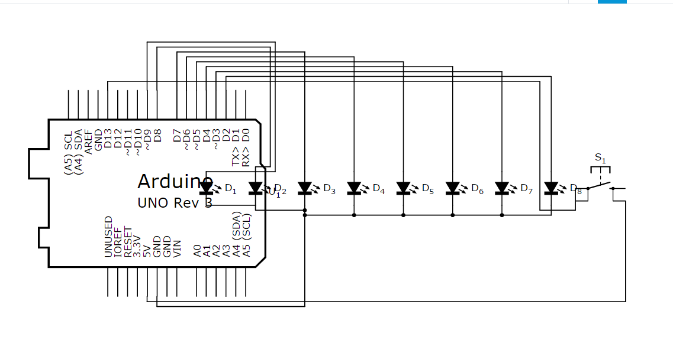
- 修正程式碼

